Technology Transfer, Appropriate technology and National Planning

Abstract
Technology transfer is a critical process to advance national technology capabilities and social development. This paper presents a proposed initiative at Tshwane University of Technology on technology transfer that is linked to ongoing work on appropriate technology. …

Keywords: technology transfer, public policy, appropriate technology, national planning

Paper category: Knowledge and technology transfer

INTRODUCTION
Appropriate technology is primarily concerned with empowering people and communities. The International Network on Appropriate Technology (INAT) has organized
…

METHODOLOGY
This study examines the relationship between technology transfer, appropriate technology and national policy planning. Each of these three are presented as a system with …

RESULTS AND DISCUSSION

Technology Transfer
Ramanathan (2013) indicates two types of technology transfer: 1) a vertical transfer of technology from basic research to applied research, then on to development, and …

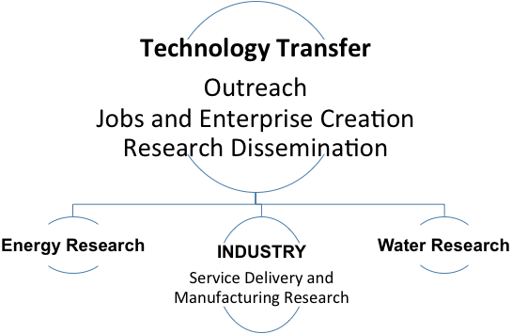

Figure 1: Technology transfer Framework and Research Focus Areas

In the broad framework of Technology transfer, the TUT Flagship Initiative considers appropriate technology to be a vital cross-cutting theme. It plays a long standing role in the author’s ongoing research (Author 2013, Author 2015).
The task of the African intelligentsia in all disciplines is to seek to develop a revolutionary agenda of action that uses their skills, resources and infrastructures to empower people and move us closer to a society where communities control their natural resources and direct the distribution of the outputs of all industry. Appropriate technology has been identified as technology aimed at empowering people. It first looks at meeting the basic needs of people while utilizing local resources and remaining accountable to sustaining an ecological balance.
“Appropriate Technology (AT) is technology that is culturally sensitive yet ecologically sound and economically sustainable. To fully embrace AT, one must be driven by compassion for humankind and Mother Earth and philosophically rooted in the belief that humanism, collectivism and egalitarianism are abiding human characteristics that heighten a collective conscience across society globally.” (Author and Muchie 2015)
In 1998, an appropriate technology agenda emerged from efforts based at Howard University with African students. This agenda expanded internationally …

Table 1: International Conferences on Appropriate Technology (ICAT)
Year | Focus | Location
2004 | Land-based projects | Bulawayo, Zimbabwe
2006 | Health related appropriate technology | Bulawayo, Zimbabwe
2008 | Energy solutions in the Era of Climate Change | Kigali, Rwanda
2010 | Water and Sanitation | Accra, Ghana
2012 | Linking education, research & practice to inform policy | Pretoria, South Africa
2014 | Technological Innovation to Empower Africa | Nairobi, Kenya
2016 | Bridging Theory with Practice | Victoria Fall, Zimbabwe

CONCLUSIONS
The TUT Flagship Initiative serves as an example of how industry, government and a university can engage in a technology transfer partnership to foster the advancement of …

References
Chomsky, N. and R. McChesney. 2011. Profit over People: Neo-liberalism & Global Order. New York: Seven Stories Press.
Feature. 2015. Urban water: World’s cities increasingly water insecure new study shows. The Water Wheel. http://reference.sabinet.co.za/document/EJC179547
Lui, S. Fang, Z, Shi, H, Guo, B. (Ed.) 2010. Theory of Science and Technology transfer and Applications. Boca Raton, FL: CRC Press, Taylor and Francis.
Mirza, F. 2013. Postal big data holds key to global development. Union Postale. No.4 p.13-16.
Schumacher, EF. 1973. Small is Beautiful: Economics as if People Mattered. New York: Harper Perennial. Reprint edition (2010).
Speser, P. 2011. The Art and Science of Technology Transfer, John Wiley & Sons, Inc. Hoboken, New Jersey, USA
Author, J. 2016. Postal Service Development Requires ICT and Big Data. Plenary Presentation for ADMI National Conference. Winston-Salem,NC (unpublished)

